Visvesvaraya Technological University
Belgaum, Karnataka-590 014


A MINI PROJECT REPORT

On

MENTOR MANAGEMENT SYSTEM

Submitted

In partial fulfilment requirements for the award of the Degree

of

BACHELOR OF ENGINEERING

IN

INFORMATION SCIENCE AND ENGINEERING

by
Nagaratna Shripad Hegde 4CB17IS028
H Niriksha Shervegar 4CB17IS013

Under the Guidance of

Mrs. Shilpa B

_{Assistant Professor}



Department of Information Science and Engineering Canara Engineering College , Benjanapadavu
2019-2020

CANARA ENGINEERING COLLEGE
BENJANAPADAVU, BANTWAL- 574219 – KARNATAKA

DEPARTMENT OF INFORMATION SCIENCE & ENGINEERING



CERTIFICATE

This is to certify that the project work entitled “MENTOR MANAGEMENT SYSTEM” is a bona fide work carried out by Ms. Nagaratna Shripad Hegde bearing USN 4CB17IS028 & Ms. H Niriksha Shervegar bearing USN 4CB17IS013, in partial fulfilment for the award of degree of Bachelor of Engineering in Information Science and Engineering under the Visvesvaraya Technological University, Belgaum during the year 2019-2020. It is verified that all corrections/suggestions indicated for internal assessment have been incorporated in the report deposited in the department library. The project report has been approved as it satisfies the academic requirements in respect of project work prescribed by Bachelor of Engineering Degree.

Project Guide H.O.D
Mrs. Shilpa B Dr. Sumathi Assistant Professor Associate Professor

Name of the Examiners Signature with Date

1.

2.
ABSTRACT

The most probable issue in today’s school and college environment is mentoring the students and keeping records of the students and mentors in a most organized way. Therefore, in this project the console application which has well-structured mentor and student record management system. This is a real time application system which uses files to store the information of students and mentors. This mini-project is very flexible to the mentors, because they can do various operations on the records such as searching the students, deleting the record, displaying the records of those students who have the marks below average in the exams. So, this system is very efficient than the hand-written register record because of efficient searching and storage mechanism. This presents a wide knowledge of file structures in C++ programming language including its characteristics

ACKNOWLEDGEMENT

We are indebted to our Principal, Dr. Ganesh V. Bhat and management of Canara Engineering College for providing an environment with all facilities that helped us in completing our mini project.
We are extremely grateful to Dr. Sumathi, Head of Information Science & Engineering Department for her moral support and encouragement.
We wish to express our sincere gratitude to our project guides Mrs. Shilpa B, Mr. Ramesh Nayak from Information Science & Engineering Department, for their guidance and suggestions.
We thank all the teaching and non-teaching staff of Department of Information Science & Engineering for their kind help.

Name of Student USN

TABLE OF CONTENTS

Page No

Abstract i
List of Figures iv
1. Introduction 1
1.1 Introduction to File Structures 1
1.2 Introduction to Mentor Management System 1
1.2.1 Problem Statement 1
1.2.2 Scope 2
2. Literature Survey 4
3. Requirement Specification 7
3.1 Project Requirements 7
3.1.1 Hardware Requirements 7
3.1.2 Software Requirements 7
4. Design 8
4.1 Algorithm 8
4.2 Data Flow Diagram 9
5. Implementation 10
5.1 User Defined Functions 10
5.2 Program Code 13
6. Results 25
6.1 Screenshots 25
7. Conclusion and Future Work 29
References 30
LIST OF FIGURES

Page No
Fig 2.1 Literature Survey 5
Fig 4.1 Data Flow Diagram 9
Fig 6.1 Choices 25
Fig 6.2 Faculty Insert 25
Fig 6.3 Faculty Display 26
Fig 6.4 Faculty Search 26
Fig 6.5 Faculty Delete 26
Fig 6.6 Student Insert 27
Fig 6.7 Student Display 27
Fig 6.8 Student Search 28
Fig 6.9 Student Delete 28
Fig 6.10 Below Average Students 28

CHAPTER 1
INTRODUCTION
1.1 Introduction to File Structures
In computing, a file system is used to control how data is stored and retrieved. Without a file system, information placed in a storage medium would be one large body of data with no way to tell where one piece of information stops and the next begins. By separating the data into pieces and giving each piece a name, the information is easily isolated and identified. Taking its name from the way paper-based information systems are named, each group of data is called a “file”. The structure and logic used to manage the groups of information and their names is called as “file system”.
There are many different kind of file systems. Each one has different structure and logic, properties of speed, flexibility, security, size and more. Some file systems have been designed to be used for specific applications.
File systems can be used on numerous different types of storage devices that use different kinds of media. The most common storage device in use today is a hard disk drive. Other kinds of media that are used include flash memory, magnetic tapes, and optical discs. In some cases such as with temporary file storage facility, the computer’s main memory(RAM) is used to create a temporary file system for short-term use.
1.2 INTRODUCTION TO THE MENTOR MANAGEMENT SYSTEM
Mentoring is very complex. It varies from one situation to another. It is interpreted in different ways by different people. It is important that the purpose and intentions of mentoring in a particular context are explicit. Stakeholders particularly mentor and mentee, should debate what mentoring is to be in their particular context in order that a mutual understanding and vision of mentoring can be shared as they embark on their relationship.
Here, the implemented code student-teacher mentoring program. In this code there are two files. One file is for teachers (Mentors) and other for student information. The file for mentors is having information of mentor i.e. faculty identification number, name, phone number and the number of student under that faculty. The other file will have all the information regarding student’s University Seat Number, name, branch, semester, marks in all six subjects.

1.2.1 PROBLEM STATEMENT
According to the statistics 80 percent of students at school and college level are not getting proper mentoring now-a-days. For the better growth of students proper mentoring is required and the proposing solution gives a good interface for mentoring.

1.2.2 SCOPE
Leading indicators help in predicting an outcome, which allows schools to make adjustments where necessary. These indicators provide early signals of progress towards growth and achievement. It is important for the school management to identify successful turnaround and examine the factors that contribute success. Eventually, determine when a turnaround is going off track as early as possible for a quick and effective response.
Leading indicators provide clear and measurable information that the school is on the right track to achieve improvement in the academic area. Further analysis is needed to identify the targets and reach achievement goals. The leading indicators for school improvement include the following.
1. Improved instructional quality in school
This includes the quality of instructions from the teacher to the student. Examples include:
- Effectiveness of the teacher
- Leader effectiveness
- Distribution of highly trained and quality teachers
- The total number of students taught by effective and efficient teachers
- Number of advanced placement
- Setting of objectives and providing feedback
- Encouraging the students to engage in group discussions
- Calling for self-grading and self-assessment for students
- Establishing learning groups among students and supporting reciprocal teaching to teaching to teachers
2. Increased participation in school
- The attendance of teachers
- The turnover rate of teachers in the school and ensure that you prevent ineffective teachers from transferring to other schools
- Provide a job-embedded professional development to support the teachers and students during the evaluation process
- The attendance rate of teachers
- Truancy rate of the students in the school
- Student’s turnover rate
- Dropout rate of the students in the school
- School participation on state assessment programs
- Create a transparent teacher evaluation process to provide opportunities for observation and collaboration
3. Improved School Culture
- Discipline incidents of students in the school
- Student’s waiting list
- Satisfaction of student, teacher, and aren’t
4. Overall targets
Targets are set after reviewing how researches define the scholars in need of turnaround interventions. Each target represents a specific milestone. If school meets its target, the school is no longer considered as the lowest performing school anymore. If a school meets its minimum target, it is considered to have made significant achievements and gains which show a good track for reaching high levels of performance.

CHAPTER 2
LITERATURE SURVEY
A Literature Survey in a project report represents the study done to assist in the completion of a project. A literature survey also describes a survey of the previous existing material on a topic of the report. Literature surveys provide brief overviews or a summary of the current research on topics. The structure written requires to be in a way that it seemed logical. It needs to chronologically represent a development of the ideas in the field that is being researched.
Research Papers related to Mentoring System
- Online Mentoring System (OMS) uses asynchronous, electronic communications to establish and support the relationship between mentor and the student using virtual mode. E-Mentoring uses computerized medium to transfer knowledge and skills from teacher to student. It basically focuses on student and faculty relationship. Online Mentoring System is a Client Server model, which acts as an Interface between Teacher and Student. OMS strive to reduce the work load of students in entering their details and at the same time enable the Mentors to assess their students more efficiently. Online Mentoring is fundamentally developed to improve the performance of students by assisting mentors to understand the problems of students more effectively and easily. In order to achieve this, a rating system is also included using which mentors can easily evaluate and sort the performance of the students and concentrate on those who need their guidance. Matching algorithm is used in this system. The implementation of the project is done using PhP and MySql.
- Student Mentoring and Assessment (SMA) is a software where the academic and extra-curricular performance of each and every student in an institution will be stored in a central computer server system over a period of time and a unique Identification Number for each student will be used to have the record of each and every student in a computer server. The software SMA implements the concept of ERP, which is business management software that provides real time view of core business process and facilitates information flow between all business functions.
- E-mentoring System uses asynchronous, electronic communications to establish and support the relationship between mentor and the student using virtual mode. E-Mentoring uses electronic medium to transfer knowledge and skills from mentor to student. It primarily focuses on student and faculty relationship. E-Mentoring System is a Client-server model, which acts as an Interface between Mentor and student. It strives to reduce the work load of students in entering their details and at the same time enable the Mentors to assess their students more efficiently. E-Mentoring is fundamentally developed to improve the performance of students by assisting mentors to understand the problems of students more effectively and easily. In order to achieve this, a rating system is also included using which mentors can easily evaluate and sort the performance of the students and concentrate on those who need there guidance.

Paper | Interface  Used | Technology  Used | Mode of  Control | Result  Analysis | Usage | Provision  of new features
[1] | J2EE  MySQL | Java, DBMS | Semi-Automatic | Not available | In large scale applications only (big institutions) | No
[2] | Web | ERP (Enterprise Relationship  Management) | Semi-Automatic | Not-available | Business fields and in mid-level schools | No
[3] | Web app  (Tomcat Server) | J2EE and MySQL | Semi-Automatic | Available | Colleges and schools where large database is required | No
Proposed  project | Console  Application | File Structures | Semi-automatic | Available | Used where ease of use is important | Yes
Fig 2.1 Literature Survey

As shown in Fig 2.1 in the project there are all the features that have replicated in the research paper. All three research papers are based on web application and they have used J2EE, ERP, J2EE respectively in technical field. All the projects are semi-automatic because no one has built the actual real life website. All of them have built a localhost and implemented universally accessible website. All three projects can be used in mid and large-level institutions because setting up the localhost and database is quite difficult work. No paper has mentioned the future work and the working model in the paper.
So, the project is implemented keeping in mind that it should be easily implemented in small level schools and colleges also with less training and less set up. So, the idea is using files instead of using any database because in small level connection and understanding database can be difficult task. Keeping all of these in mind the project is implemented as a console application using C++ files.

CHAPTER 3
REQUIREMENYT SPECIFICATION
3.1 PROJECT REQUIREMENTS
3.1.1 HARDWARE REQUIREMENTS
- Processor - 800MHz
- RAM - 512MB
- Hard Disc - 20MB

3.1.2 SOFTWARE REQUIREMENTS
- Operating System - Windows/Linux
- Front-end - CodeBlocks

CHAPTER 4
DESIGN
4.1 ALGORITHM
Step 1 : Start
Step 2 : Create two file for record and index file
- Index file contain primary key, secondary key
- Record file contains all attributes
Step 3 : Insert the records into the files having ‘|’ as the separator for each attributes and sort the file according to the names
Step 4 : If the average marks is below 20 then add the name to the array of below Average Students
Step 4 : to search the record required
- Search the index file bases on secondary key
Step 5 : search based on primary key in index file
Step 6 : display the content of record file and index file
Step 7 : to delete record first perform search
Step 8 : match the record file then
- If match found delete the record
- Else print the error message
Step 9 : to display below average students iterate through belowAvergaeStudents array and print it
Step 10 : If the choice is 10 then stop else ask user to enter choice
4.2 FLOW CHART
Start

Main Menu

Input

Switch

case
3

case
4

case
5

case
6

case
7

case
1
case
2

Add
Faculty
Add
Student
Delete
faculty
Search
faculty
Search
Student
Delete
Student
Display
Faculty

case
8

case
10

case
9

End
Display
Student
Below average
Students

Fig 4.1 Flow Chart

CHAPTER 5

IMPLEMENTATION

5.1 USER DEFINED FUNCTIONS

createIndex() :

This function is used to create secondary indexing for the faculty file (61.txt)
Input : No input
Output : No output

createIndex1() :

This function is used to create secondary indexing for the student file (6.txt)
Input : No input
Output : No output

fdisp() :

This function prints the faculty name in the mentoring system. While entering the details faculty name is stored in a String array and using that array this function prints the name.
Input : It takes no input
Output : Output is the name of faculties in mentoring system

disp() :

This function prints the student name in the mentoring system. While entering the details student name is stored in a String array and using that array this function prints the name.
Input : It takes no input
Output : Output is the name of students in mentoring system

finsert() :

This function is used to insert the faculty details into the file and it asks the details from the user and stores it in a file and names are stored in a String array. It checks input format using regular expressions.
Input : FID, faculty name, phone number, number of students
Output : It inserts all the details into the file and outputs nothing

insertStudent() :

This function is used to insert the student details into the file and it asks the details from the user and stores it in a file and names are stored in a String array. It checks input format using regular expressions.
Input : usn, name, branch, phone number, semester, 6 subject marks, mentor name
Output : It inserts all the details into the file and outputs nothing
dispAverageStudent() :

This function displays the name of those students who have the score below average(20).While inserting the details of the student average marks is calculated and checked if the marks is below average then it is inserted into a different String array. Using this array it prints the name of the students.
Input : Nothing
Output : Name of the students who have average marks below average

removeFromAverage() :

This function removes the name from the string array when a student record is removed from the file. This function is triggered when removeRecord function is called
Input : Nothing
Output : Removes the name of the student from the array is it is deleted from the file

removeRecord() :

It takes a string as a parameter which is the name of the students that has to be removed and searchs the name in the file if it exists then it removes the record else it prints an error message that student record does not exist.
Input : Nothing
Output : Deletes the record if exists

fremove() :

It takes a string as a parameter which is the name of the faculty that has to be removed and searchs the name in the file if it exists then it removes the record else it prints an error message that faculty record does not exist.
Input : Nothing
Output : Deletes the record if exists

readFromFile() :

It takes an integer parameter that is used to search a faculty record in the file by using the address of the record in the file
Input : position of the record
Output : Record of the faculty

readFromStudent() :

It takes an integer parameter that is used to search a student record in the file by using the address of the record in the file
Input : position of the record
Output : Record of the student

delFromFile() :

It also takes position as integer parameter and searches the faculty file for the record and it will put the ‘*’ character in the beginning to denote the record is no longer exists in the file
Input : Position as a parameter
Output : Record deleted

delFromStudent() :

It also takes position as integer parameter and searches the student file for the record and it will put the ‘*’ character in the beginning to denote the record is no longer exists in the file.
Input : Position as a parameter
Output : Record deleted

extractName() :

It takes the whole line of a file as the string parameter and extracts the name from that line and returns that name as string.
Input : Line of the file as string parameter
Output : returns name from that line

fsortIndex() :

Sorts the faculty name array by it’s name using bubble sort algorithm.
Input : No inputs
Output : Sorts the faculty array but prints nothing

sortIndex() :

Sorts the student name array by its name using bubble sort algorithm.
Input : No inputs
Output : Sorts the student array but prints nothing

searchIndex() :

It takes student name as the string parameter and search the student array using binary search algorithm and returns the position of that student in the array
Input : Student name as string parameter
Output : position of the student in the array if it exists else it returns -1

fSearchIndex() :

It takes faculty name as the string parameter and search the faculty array using binary search algorithm and returns the position of that faculty in the array
Input : Faculty name as string parameter
Output : position of the faculty in the array if it exists else it returns -1

5.2 PROGRAM CODES

/* *********************MENTOR MANAGEMENT SYSTEM*********************************
Input Formats:
STUDENT:
USN : 4CB1[0-9]IS[0-9][0-9][0-9]
BRANCH : ISE
SEM : 1-8
PHONE NUMBER : 10 digit number
MARKS : 0-20
ATTEDNDANCE : 0-100

FACULTY:
FID : [A-Z][0-9]
PHONE NUMBER : 10 DIGIT NUMBER
NUMBER OF STUDENTS : 0-9

*/

#include<stdio.h>
#include<stdlib.h>
#include<iostream>
#include<fstream>
#include<string>
#include<regex>

using namespace std;
class secondary_index{
public:
string name_list[100],student[100],beloAverageStudent[100];
int counter,address_list[100],studentadr[100],averageCounter = 0;
int averageMark[100];
/*name_list[] : Faculty Names
i : Iterator
student[] : student names
belowAverageStudent: names of students who have marks below average
counter : number of records
address_list[] : index of faculties in file
studentaddr[] : index of studentaddr in file
acerageCounter : count of below average students
*/
void finsert(); //Faculty insert function
void insertStudent(); //Student Insert function
void fdisp(); //Faculty display function
void disp(); //Student display function
void dispAverageStudent(); //below average students display function
void removeRecord(string); //Student record remove function
void removeFromAverage(string);
void fremove(string); //Faculty remove function
void fsearch(string); //Faculty search
void readFromFile(int); //reading from faculty file
void readFromStudent(int); //reading from student file
void delFromFile(int); //Deleting from Faculty file
void delFromStudent(int); //Deleting from student file
string extractName(string); //extracting name from student file
void createIndex(); //Initialising student file 6.txt
void createIndex1(); //Initialising faculty file 61.txt
void fsortIndex(); //Sorting name_list[](faculty name) by their name(alphabetically)
void sortIndex(); //Sorting student[] (students name) by their name(alphabetically)
int searchIndex(string); //Searching students by giving name as parameter
int fSearchIndex(string); //Searching faculty by giving name as parameter
};

void secondary_index :: fdisp(){
int i;
cout<<"\n\t\t\t\t\t\t FACULTY INDEX FILE"<<endl;
if(name_list[0] == ""){
cout<<"\n\t\t\t NO RECORDS OF FACULTIES YET"<<endl;
return;
}
for(i=0;i<=counter;i++)
cout<<name_list[i]<<endl;
}

void secondary_index :: disp(){
int i;
cout<<"\n\t\t\t STUDENT INDEX FILE"<<endl;
if(student[0] == ""){
cout<<"\n\t\t\t NO STUDENT RECORDS YET"<<endl;
return;
}
for(i=0;i<=counter;i++)
cout<<student[i]<<endl;
}

void secondary_index :: dispAverageStudent(){
int i;
if(beloAverageStudent[0] == ""){
cout<<"NO BELOW AVERAGE STUDENTS YET"<<endl;
return;
}
cout<<"\n\t\t\tBELOW AVERAGE STUDENTS"<<endl;
for(i=0;i<averageCounter;i++){
cout<<beloAverageStudent[i]<<"\t\t"<<averageMark[i]<<endl;
}
}

void secondary_index :: createIndex(){
fstream fp;
int pos;
string buffer,name;
counter = -1;
fp.open("61.txt",ios::in);
while(!fp.eof()){
pos = fp.tellg();
buffer.erase();
getline(fp,buffer);
if(buffer[0]!= '*'){
if(buffer.empty())
break;
name = extractName(buffer);
name_list[++counter] = name;
address_list[counter] = pos;
}
}
fp.close();
fsortIndex();
buffer.erase();
}

void secondary_index :: createIndex1(){
fstream fp;
int pos;
string buffer,name;
counter = -1;
fp.open("6.txt",ios::in);
while(!fp.eof()){
pos = fp.tellg();
buffer.erase();
getline(fp,buffer);
if(buffer[0]!= '*'){
if(buffer.empty())
break;
name = extractName(buffer);
student[++counter] = name;
studentadr[counter] = pos;
}
}
fp.close();
fsortIndex();
buffer.erase();
}

string secondary_index :: extractName(string buffer){
string usn,name;
int i=0;
usn.erase();
while(buffer[i] != '|') // | is indicator because after each entity concatenated it with '|' , see 6.txt file
usn+= buffer[i++];
name.erase();
i++;
while(buffer[i] != '|')
name+= buffer[i++];
return name;
}

void secondary_index :: fsortIndex(){
//Bubble sort algorithm
int i,j,tempAddress;
string tempName;
for(i=0;i<=counter;i++)
for(j=i+1;j<=counter;j++)
if(name_list[i] > name_list[j]){
tempName = name_list[i];
name_list[i] = name_list[j];
name_list[j] = tempName;

tempAddress = address_list[i];
address_list[i] = address_list[j];
address_list[j] = tempAddress;
}
}

void secondary_index :: sortIndex(){
//Bubble Sort
int i,j,tempAddress;
string tempName;
for(i=0;i<=counter;i++)
for(j=i+1;j<=counter;j++)
if(student[i] > student[j]){
tempName = student[i];
student[i] = student[j];
student[j] = tempName;

tempAddress = studentadr[i];
studentadr[i] = studentadr[j];
studentadr[j] = tempAddress;
}
}

void secondary_index :: insertStudent(){
regex USN("4CB1[0-9]IS[0-9][0-9][0-9]");
regex SEM("[1-8]");
regex BRANCH("ISE");
regex PHNO("[0-9][0-9][0-9][0-9][0-9][0-9][0-9][0-9][0-9][0-9]");
//Regular expressions are used to get the desired format of inputs
string mentor,attendance,usn,name,branch,sem,buffer,phno,m1,m2,m3,m4,m5,m6;
int pos,n,i,j,k,d,usnFlag;
int average;
int mark1,mark2,mark3,mark4,mark5,mark6;
fstream fp;
buffer.erase();

cout<<"\n\t\tEnter the number of students";
cin>>n;
outer : for(i=0;i<n;i++){
usnFlag = 0;
cout<<"\n\t\tEnter student details"<<endl;
cout<<"\n\t\tUSN: ";
cin>>usn;
for(d=0;d<=counter;d++)
if(usn.compare(student[i])){
usnFlag = 1;
break;
}
if(usnFlag){
cout<<"\n\t\t\t USN ALREADY EXISTS"<<endl;
continue;
}
//regex_match(a,b) compares the regular language of a and b
if(!regex_match(usn,USN)){
cout<<"\n\t\tUSN invalid"<<endl;
continue;
}
cout<<"\n\t\tNAME: ";
cin>>name;
cout<<"\n\t\tBRANCH: ";
cin>>branch;
if(!regex_match(branch,BRANCH)){
cout<<"\n\t\tOnly ISE branch allowed"<<endl;
continue;
}
cout<<"\n\t\tSEMESTER: ";
cin>>sem;
if(!regex_match(sem,SEM)){
cout<<"\n\t\tOnly 1-8 semester entry allowed"<<endl;
continue;
}
cout<<"\n\t\tPHONE NUMBER: ";
cin>>phno;
if(!regex_match(phno,PHNO)){
cout<<"\n\t\tInvalid phone number format"<<endl;
continue;
}
cout<<"\n\t\tSUBJECT1 MARKS: ";
cin>>m1;
if(stoi(m1)<0 || stoi(m1) > 30){
cout<<"\n\t\tInvalid marks value"<<endl;
continue;
}
cout<<"\n\t\tSUBJECT2 MARKS: ";
cin>>m2;
if(stoi(m2)<0 || stoi(m2) > 30){
cout<<"\n\t\tInvalid marks value"<<endl;
continue;
}
cout<<"\n\t\tSUBJECT3 MARKS: ";
cin>>m3;
if(stoi(m3)<0 || stoi(m3) > 30){
cout<<"\n\t\tInvalid marks value"<<endl;
continue;
}
cout<<"\n\t\tSUBJECT4 MARKS: ";
cin>>m4;
if(stoi(m4)<0 || stoi(m4) > 30){
cout<<"\n\t\tInvalid marks value"<<endl;
continue;
}
cout<<"\n\t\tSUBJECT5 MARKS: ";
cin>>m5;
if(stoi(m5)<0 || stoi(m5) > 30){
cout<<"\n\t\tInvalid marks value"<<endl;
continue;
}
cout<<"\n\t\tSUBJECT6 MARKS: ";
cin>>m6;
if(stoi(m6)<0 || stoi(m6) > 30){
cout<<"\n\t\tInvalid marks value"<<endl;
continue;
}
cout<<"\n\t\tENTER MENTOR NAME: ";
cin>>mentor;
cout<<"\n\t\tATTENDANCE: ";
cin>>attendance;
if(stoi(attendance)< 0 || stoi(attendance) > 100){
cout<<"\n\t\tInvalid attendance value"<<endl;
continue;
}
//stoi() is used tp convert string to integer
mark1 = stoi(m1);
mark2 = stoi(m2);
mark3 = stoi(m3);
mark4 = stoi(m4);
mark5 = stoi(m5);
mark6 = stoi(m6);
average = (mark1 + mark2 + mark3 + mark4 + mark5 + mark6)/6;
buffer = usn + "\t|\t" + name + "\t|\t" + branch + "\t|\t" + phno + "\t|\t" + m1 + "\t|\t" + m2 + "\t|\t" + m3 + "\t|\t" + m4 + "\t|\t" + m5 + "\t|\t" + m6 + "\t|\t" + mentor + "\t|\t" + attendance + "$\n";
fp.open("6.txt",ios::out|ios::app);
pos = fp.tellp();
fp<<buffer;
fp.close();
student[++counter] = name;
studentadr[counter] = pos;
if(average < 18){ //need not be 18
beloAverageStudent[averageCounter] = name;
averageMark[averageCounter] = average;
averageCounter++;
}
sortIndex();
cout<<"\n\t\tStudent Details Recorded Successfully"<<endl;
}
}

void secondary_index :: finsert(){
string st1,st2,fid,name,buffer,phno,st_name[10],number;
regex FID("[A-Z][0-9]"); //Format of ID should be 'A4' 'B8' like this.
regex PHNO("[0-9][0-9][0-9][0-9][0-9][0-9][0-9][0-9][0-9][0-9]");
regex NUMBER("[1-9]");
int k,pos,m,i,j;
fstream fp;
buffer.erase();
cout<<"\n\t\tENTER Faculty DETAILS"<<endl;
cout<<"\n\t\tFID: (format [A-Z][0-9])";
cin>>fid;
if(!regex_match(fid,FID)){
cout<<"\n\t\tInvalid fid"<<endl;
return;
}
cout<<"\n\t\tNAME: ";
cin>>name;
cout<<"\n\t\tPHONE: ";
cin>>phno;
if(!regex_match(phno,PHNO)){
cout<<"\n\t\tInavlid phone number format"<<endl;
return;
}
cout<<"\n\t\tEnter number of students";
cin>>number;
if(!regex_match(number,NUMBER)){
cout<<"\n\t\tOnly maximum 9 students can be allotted"<<endl;
return;
}
buffer = fid + "\t|\t" + name + "\t|\t" + phno + "|"+ number +"$\n";
fp.open("61.txt",ios::out|ios::app);
pos = fp.tellp();
fp<<buffer;
fp.close();
name_list[++counter] = name;
address_list[counter] = pos;
fsortIndex();
cout<<"\n\t\tFaculty Inserted Successully"<<endl;
}

void secondary_index :: readFromStudent(int pos){
int address,i;
string buffer;
fstream fp;
fp.open("6.txt",ios::in);
address = studentadr[pos];
fp.seekp(address,ios::beg);
getline(fp,buffer);
cout<<"\n\t\t\t\t Found the record:"<<buffer;
fp.close();
}

void secondary_index ::readFromFile(int pos){
int address,i;
string buffer;
fstream fp;
fp.open("61.txt",ios::in);
address = address_list[pos];
fp.seekp(address,ios::beg);
getline(fp,buffer);
cout<<buffer;
fp.close();
}

void secondary_index :: fremove(string key){
int pos = 0,t,choice;
string buffer;
buffer.erase();
pos = fSearchIndex(key);
if(pos == -1)
cout<<"\n\t\t\t Record not found"<<endl;
else if(pos>=0){
readFromFile(pos);
delFromFile(pos);
t = pos;
while(name_list[t] == key && t>=0){
readFromFile(t);
delFromFile(t);
t++;
}
}
}

void secondary_index :: removeRecord(string key){
int pos = 0,t,choice;
string buffer;
buffer.erase();
pos = searchIndex(key);
if(pos == -1)
cout<<"\n\t\t\t Record not found"<<endl;
else if(pos>=0){
removeFromAverage(key);
readFromStudent(pos);
delFromStudent(pos);
t = pos;
while(name_list[t] == key && t>=0){
readFromStudent(t);
delFromStudent(t);
t++;
}
}
}

void secondary_index :: removeFromAverage(string key){
int k,flag = 0,position;
for(k=0;k<averageCounter;k++){
if(beloAverageStudent[k] == key){
flag = 1;
position = k;
break;
}
}
if(flag){
for(k=position;k<averageCounter;k++){
beloAverageStudent[k] = beloAverageStudent[k+1];
averageCounter--;
}
}
}

void secondary_index :: delFromFile(int pos){
char delch = '*';
int i,address;
fstream fp;
fp.open("61.txt");
address = address_list[pos];
fp.seekp(address,ios::beg);
fp.put(delch);
cout<<"\n\t\t\t\t Record deleted"<<endl;
for(i=pos;i<counter;i++){
name_list[i] = name_list[i+1];
address_list[i] = address_list[i+1];
}
counter--;
}

void secondary_index :: delFromStudent(int pos){
char delch = '*';
int i,address;
fstream fp;
fp.open("6.txt");
address = studentadr[pos];
fp.seekp(address,ios::beg);
fp.put(delch);
cout<<"\n\t\t\t\t Record deleted"<<endl;
for(i=pos;i<counter;i++){
student[i] = student[i+1];
studentadr[i] = studentadr[i+1];
}
counter--;
}

int secondary_index :: searchIndex(string key){
int low=0,high = counter,mid=0,flag = 0,pos;
while(low<=high){
mid = (low+high)/2;
if(student[mid] == key){
flag = 1;
break;
}
if(student[mid] > key)
high = mid - 1;
if(student[mid] < key)
low = mid + 1;
}
if(flag){
readFromStudent(mid);
return mid;
}
else{
cout<<"\n\t\t\tStudent Not Found"<<endl;
return -1;
}
}

int secondary_index :: fSearchIndex(string key){
int low=0,high=counter,mid=0,flag = 0,pos;
while(low<=high){
mid = (low+high)/2;
if(name_list[mid] == key){
flag = 1;
break;
}
if(name_list[mid] >key)
high = mid - 1;
if(name_list[mid] < key)
low = mid + 1;
}
if(flag){
cout<<"\n\t\tFaculty Found"<<endl;
readFromFile(mid);
return mid;
}
else{
cout<<"\n\t\tFaculty Not Found"<<endl;
return -1;
}
}

int main(){
int choice;
string key;
secondary_index i1,i2;
i1.createIndex();
i2.createIndex1();
cout<<"\n\t\t WELCOME TO MENTOR MANAGEMENT SYSTEM"<<endl;
while(1){
cout<<"\n\t\t\ *************************************"<<endl;
cout<<"\n\n\t\t FACULTY :\n\n\t\t\t1:Add Faculty \n\n\t\t\t2.Faculty Search \n\n\t\t\t3.Faculty Delete\n\n\n\t\t STUDENT :\n\n\t\t\t4.Add Student\n\n\t\t\t5.Student Search\n\n\t\t\t6.Student Delete\n\n\n\t\t DISPLAY:\n\n\t\t\t7.Display Faculties\n\n\t\t\t8.Display Students\n\n\n\t\t9.Below Average Students\n\n\n\n\t\t10.Exit"<<endl;
cout<<"\n\n\t\t\tEnter your choice:\t";
cin>>choice;

switch(choice){
case 1:
cout<<"\n\t\t\ *************************************"<<endl;
i1.finsert();
cout<<"\n\t\t\ *************************************"<<endl;
break;
case 2:
cout<<"\n\t\t\ *************************************"<<endl;
cout<<"\n\t\t\t Enter the name to display records:";
cin>>key;
i1.fSearchIndex(key);
cout<<"\n\t\t\ *************************************"<<endl;
break;
case 3:
cout<<"\n\t\t\ *************************************"<<endl;
cout<<"\n\t\tEnter the name to remove";
cin>>key;
i1.fremove(key);
cout<<"\n\t\t\ *************************************"<<endl;
break;
case 4:
cout<<"\n\t\t\ *************************************"<<endl;
i2.insertStudent();
cout<<"\n\t\t\ *************************************"<<endl;
break;
case 5:
cout<<"\n\t\t\ *************************************"<<endl;
cout<<"\n\t\t\t Enter the name to display records:";
cin>>key;
i2.searchIndex(key);
cout<<"\n\t\t\ *************************************"<<endl;
break;
case 6:
cout<<"\n\t\t\ *************************************"<<endl;
cout<<"\n\t\tEnter the name to remove from records:";
cin>>key;
i2.removeRecord(key);
cout<<"\n\t\t\ *************************************"<<endl;
break;
case 7:
cout<<"\n\t\t\ *************************************"<<endl;
i1.fdisp();
cout<<"\n\t\t\ *************************************"<<endl;
break;
case 8:
cout<<"\n\t\t\ *************************************"<<endl;
i2.disp();
cout<<"\n\t\t\ *************************************"<<endl;
break;
case 9:
cout<<"\n\t\t\ *************************************"<<endl;
i2.dispAverageStudent();
cout<<"\n\t\t\ *************************************"<<endl;
break;
case 10:
return 0;
default:
cout<<"\n\t\tWrong choice"<<endl;
break;
}
}
}

CHAPTER 6

RESULTS
6.1 SCREENSHOTS

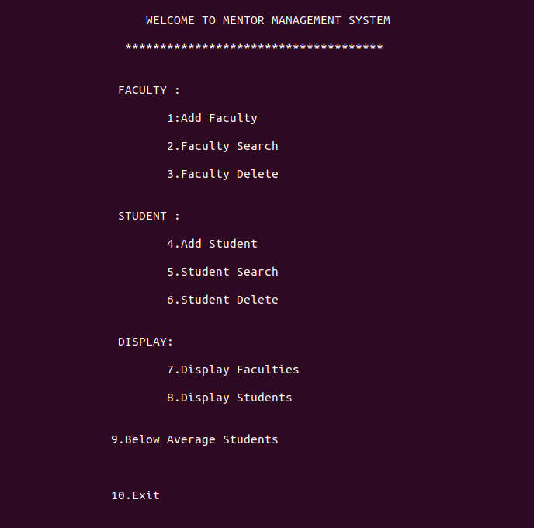
Fig 6.1 Choices

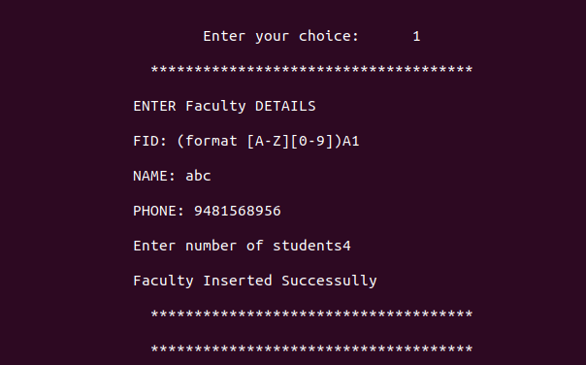
Fig 6.2 Faculty Insert

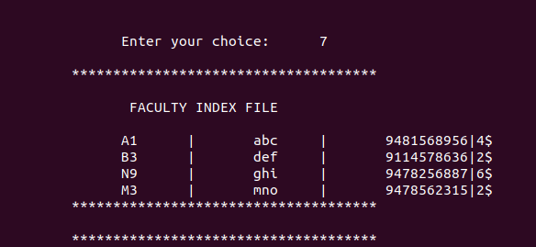
Fig 6.3 Faculty Display

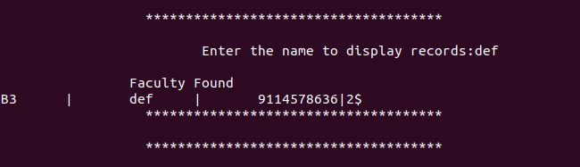
Fig 6.4 Faculty Search

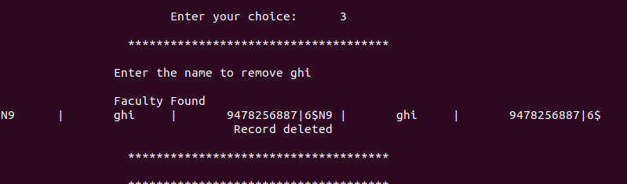
Fig 6.5 Faculty Remove

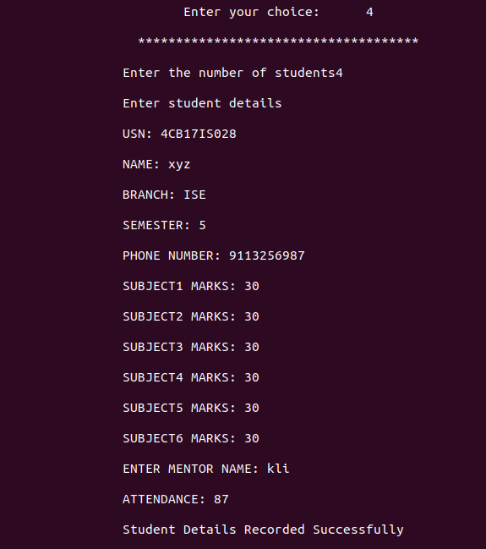

Fig 6.6 Student Insert

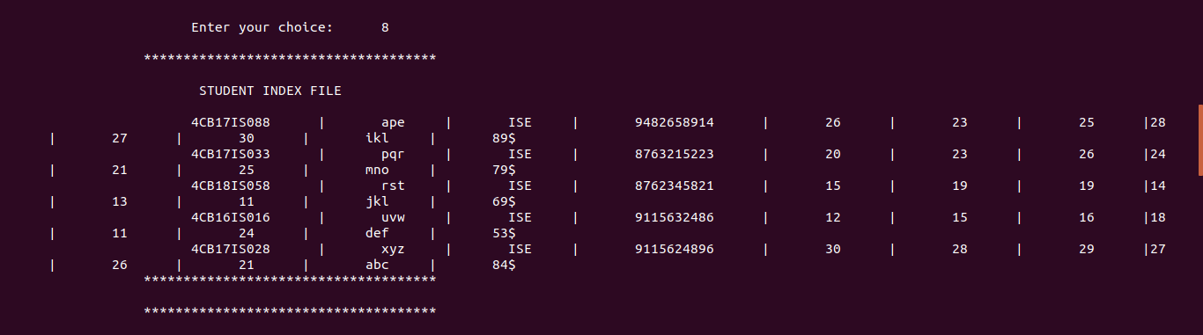
Fig 6.7 Student Display

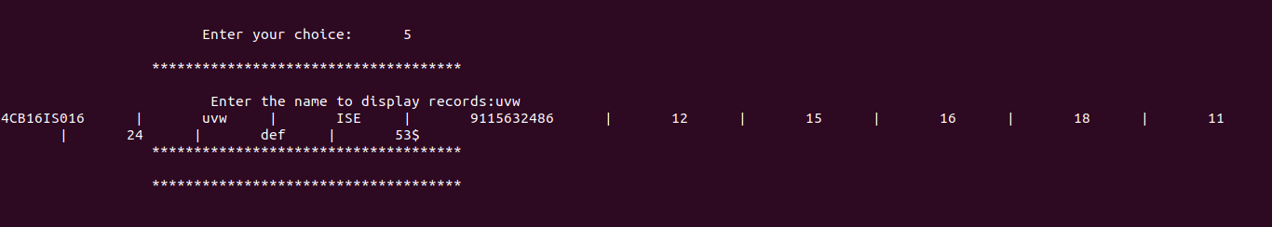
Fig 6.8 Student Search

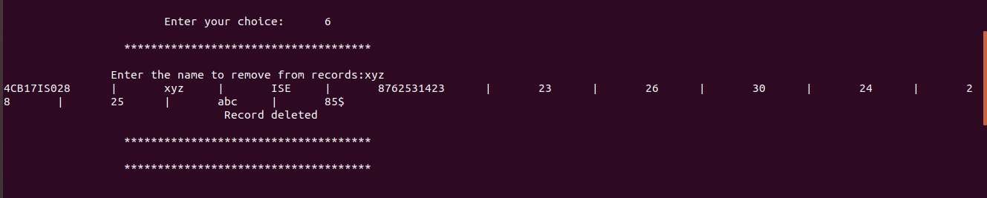
Fig 6.9 Student Delete

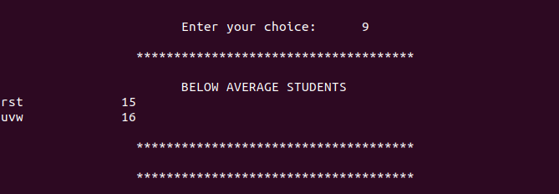
Fig 6.10 Below Average Students

CONCLUSION AND FUTURE ENHANCEMENT

After considering and evaluating the efficiency of existing model the project has much more constraints to the inputs in our projects. Usage regular expressions to take the input in desired format. The school or college can change these formats using our code. The had done work on duplicate entries from the user. So, the existing model is modified to that level where the inputs can be filtered and will maintain the format. The mentors can see those students whose marks are below average marks. So, using our system mentors can maintain solid record and trace of the students efficiently.
In future one can build a good GUI for the system using Visual Studio or in some other platform. One can integrate the dynamic attendance system with our project so that all in one format can be achieved. Integrating parent’s information of individual students and making it available only for the mentors.

REFERENCES

Referred books

[1] Michael J. Folk, Bill Zoellick, GergRichard: File Structure- An Object Oriented Approach
with C++, 3rd Edition, Pearson Education, 1998

[2] K.R. Venugopal, K.G. Srinivas, P.M. Krishnaraj: Fie Structure Using C++, Tata MCGraw-
Hill, 2008

[3] Scot Robert Ladd: C++ components and Algorithms, BPB Publications, 1993

[4] Raghu Ramakrishna and Johannes Gehkre: Database Management System, 3rd Edition, McGraw-Hill, 2003

Referred Website

[1] www.codeprojects.com
[2] www.stackoverflow.com

